[DISCLAIMER: THIS TEMPLATE IS NOT INTENDED TO BE AND SHOULD NOT BE CONSTRUED TO CONSTITUTE LEGAL ADVICE. STATE AND FEDERAL LAW MAY REQUIRE YOU TO INCLUDE SPECIFIC PROVISIONS IN YOUR TEMPLATE. THIS DOCUMENT SHOULD BE USED FOR INFORMATIONAL PURPOSES ONLY. YOU SHOULD CONSULT LEGAL COUNSEL WHEN CUSTOMIZING THIS TEMPLATE FOR YOUR ORGANIZATION'S NEEDS.]
Workplace Violence Policy

For [Home Health/Home Care/Hospice]

Introduction

Purpose of the Policy
The purpose of this Workplace Violence Policy is to provide guidance and establish procedures for [home health/home care/hospice] employees to prevent, report, and effectively respond to incidents of workplace violence, particularly when it occurs in a [client's/patient's] home. This policy aims to create a safe and supportive work environment for all employees.

Scope and Applicability
This policy applies to all employees providing home-based services within our organization. It encompasses situations where employees provide care and support to clients in their homes or other residential settings. We are committed to maintaining a work environment free from violence, threats, intimidation, or any form of abusive behavior. Ensuring the safety and well-being of our employees is of paramount importance.
We maintain a commitment to the safety and well-being of our employees working in the homes of our [clients/patients]. We operate under a zero-tolerance policy for workplace violence, ensuring that all forms of violence, threats, intimidation, harassment, or abusive behavior are strictly prohibited within our organization. We demand full compliance with this policy to create and maintain a violence-free environment for our employees and [clients/patients]. This policy underscores our unwavering dedication to providing a safe and supportive work environment and reinforces our commitment to our employees.

Roles and Responsibilities

Home-Based Employees

Reporting Incidents: It is the responsibility of all home-based employees to promptly report any incidents, threats, or concerns related to workplace violence as outlined in this policy.

Active Participation: Actively participate in de-escalation techniques training and apply these skills when needed to diffuse potentially violent situations.

Compliance: Comply with all safety protocols, procedures, and guidelines provided in this policy.

Boundaries: Establish and maintain professional boundaries with [clients/patients] and their families while ensuring personal safety boundaries are respected.

Supervisors and Managers

Immediate Response: Supervisors and managers are responsible for taking immediate action upon receiving reports of workplace violence or threats, including initiating investigations as needed.

Support and Guidance: Provide support, guidance, and resources to employees who report incidents of workplace violence. Ensure that employees feel safe and heard.

Documentation: Maintain accurate records of reported incidents, investigations, and actions taken. Track and trend incidents providing reports to managers to enhance prevention, modify training as necessary to mitigate future incidents if possible.

Training: Ensure that employees receive proper training in de-escalation techniques and proactive safety measures.

Definitions
Workplace Violence: Workplace violence refers to any physical assault, verbal abuse, intimidation, threatening behavior, harassment, or any other act that creates a hostile or unsafe work environment.
Home-Based Employee: Home-based employees include all individuals employed by the organization who provide care, support, or services to clients in a home or residential setting.
Reporting Procedures: Reporting procedures involve the process of reporting incidents of workplace violence to the appropriate authorities and channels within the organization.
Proactive Protection: Proactive protection refers to strategies and measures taken to minimize the risk of workplace violence and ensure employee safety.
De-escalation Techniques: De-escalation techniques encompass strategies and tactics to defuse tense or potentially violent situations through effective communication and conflict resolution.

Reporting Procedures

Duty to Report

All employees have a duty to report any incidents or threats of workplace violence, whether immediate or potential, that they witness or experience. Employees should us the form provided in Appendix A.

Employees should report incidents even if they are not the direct target but have reason to believe the violence may affect their safety or the safety of others.

Reporting Channels

Direct Supervisor: Employees should report incidents to their immediate supervisor or manager as soon as possible.

Human Resources Department: If an employee feels uncomfortable reporting to their direct supervisor or if the supervisor is involved in the incident, they can contact the HR department.

[if available:] Anonymous Reporting Mechanisms/1-800 Hotline: The organization may provide anonymous reporting options to encourage reporting without fear of retaliation.

Confidentiality and Non-Retaliation

All reports of workplace violence will be treated with as much confidentiality as possible given the situation and related laws.

The initiation of a good faith report of workplace violence will not be grounds for disciplinary action, even if the allegations cannot be substantiated. Any individual who makes a report of workplace violence that is demonstrated to be intentionally false may be subject to discipline, up to and including termination of employment.

Investigation Process

Upon receiving a report, the organization will promptly initiate an investigation to determine the facts surrounding the incident.

Investigations will be conducted impartially and professionally.

Employees involved in the incident may be asked to provide statements and cooperate with the investigation.

Documentation will be reviewed by the [inert your team i.e., risk management, safety committee, senior management] and determine what changes, additions or revisions of current polies and procedures are required in the future to prevent another such incident.

Consequences for intentionally false reporting of workplace violence are considered a serious violation of this policy and may result in disciplinary action, up to and including termination.

Proactive Ways to Protect Employees

Home Assessment and Safety Precautions

Initial Home Assessment: Prior to providing care, employees will conduct an assessment of the client's home environment to identify potential safety risks (Appendix B).

Ongoing Risk Assessment: Regular assessments will be performed to identify changing risk factors in the client's home. The results of these assessments are documented and reported to the care team.

Establishing Boundaries

Professional Boundaries: Employees should maintain professional boundaries with clients and their families to prevent misunderstandings or conflicts.

Personal Safety Boundaries: Employees have the right to establish personal safety boundaries and request changes to assignments or conditions if they feel unsafe.

Emergency Contact Information: Employees will have access to emergency contact information for immediate assistance in case of emergencies or security concerns.

Equipment and Tools: The safety and well-being of our employees providing home-based services are paramount. We are committed to ensuring a secure work environment. All employees engaged in home-based services are required to use appropriate safety equipment in accordance with their specific job roles and potential hazards they may encounter. This includes a whistle/personal alarm device and flashlight when potentially working at night. Additionally, employees should carry their cell phones, with GPS tracking enabled, at all times. Except as otherwise allowed by law, employees are prohibited from carrying weapons while working. Employees must use, maintain, and store safety equipment as instructed in training and adhere to all safety guidelines and procedures. Any damaged or defective equipment should be reported immediately to supervisors to ensure prompt replacement or repair. We are dedicated to providing the necessary resources to protect our employees and minimize workplace hazards, aligning with our commitment to their safety and well-being while delivering quality home-based services.

Work Scheduling and Location

Considerations for High-Risk Areas: Special considerations and precautions will be taken for assignments in high-crime or high-risk areas.

Avoiding Lone Work Situations: Whenever possible, employees should avoid working alone in potentially volatile situations.

Home Visits After Dark [This section needs to be individualized based on org. RE: buddy system financial impact, and number of on call visit required.]

Home visits after dark should only be conducted when authorized by a supervisor or manager. Employees must inform their supervisor or manager of the need for an unscheduled nighttime visit and receive approval before proceeding.

Whenever possible, home visits after dark should be conducted by two employees working together as a team. This "buddy system" enhances safety by providing mutual support and reducing vulnerability.

Employees conducting home visits after dark must carry a fully charged mobile phone and establish regular check-in times with a supervisor or colleague during the visit. If communication is lost or a check-in is missed, immediate action should be taken to ensure the employee's safety.

Personal Safety Measures
- Employees must dress appropriately for visibility, wearing reflective clothing or accessories when necessary.
- Carrying a flashlight or portable light source is recommended to improve visibility.
- Employees should park their vehicles in well-lit areas and use parking lots when available.

All visits require documentation of where the employee is going, time, reason, and contact information.

Early Termination of Home Visits. In cases where an employee perceives an immediate threat to their safety, experiences an escalating hostile situation, or encounters any other circumstance that jeopardizes their well-being during a home visit (whether during daytime or after dark), they have the authority to terminate the visit early, prioritizing their personal safety above all else. Employees should promptly and safely exit the premises and contact their supervisor or designated authority to report the situation. The organization supports and encourages employees to exercise their judgment and discretion in determining when it is necessary to conclude a home visit prematurely to ensure their safety. A debriefing and follow-up procedures will be initiated to address the circumstances surrounding the early termination of the visit and ensure the employee receives necessary support and assistance.

De-escalation Techniques & Self-Defense

Definition of De-escalation: De-escalation is the use of verbal and non-verbal communication techniques to reduce tension and hostility in potentially violent situations.

De-escalation Principles

Stay Calm and Composed: Employees should maintain their composure and emotional control.

Active Listening: Actively listen to the concerns of the client or family member.

Non-threatening Body Language: Maintain open and non-threatening body language to avoid escalating the situation.

Empathy and Respect: Show empathy and respect for the client's feelings and concerns.

De-escalation Strategies

Verbal Techniques: Use calming and empathetic language to defuse tension.

Distraction Techniques: Redirect the client's focus away from the source of conflict.

Setting Boundaries: Clearly communicate and enforce boundaries when necessary.

Offering Alternatives: Provide alternative solutions to address the client's concerns.

Reporting De-escalation Efforts: Employees should report any use of de-escalation techniques in their incident reports.

Training and Skill Development:

The organization will provide training and resources for employees to develop de-escalation skills.

The organization will provide training and resources for employees to develop self-defense skills when preventative actions do not work.

Training will be provided at hire and on an annual basis to all employees.

Escalation Procedures

When De-escalation Fails: If de-escalation efforts are unsuccessful or the situation worsens, employees should immediately call for assistance.

Contacting Authorities: If there is an imminent threat to safety, employees should contact local law enforcement.

Ensuring Personal Safety: Employees should prioritize their personal safety and the safety of clients and bystanders.

Support and Resources

Medical – Injured employees will be provided first aid and emergency care.

Employee Assistance Program (EAP) – Employees have access to counseling and support services through the EAP for dealing with the emotional impact of workplace violence.

Counseling Services – Referrals to counseling services will be provided for employees who require additional support. To the extent possible, trauma-informed psychological counseling will be used.

Legal Protections – Employees will be informed of their legal rights and protections under state and federal laws.

Victim Support Organizations – Information about local victim support organizations will be made available to employees.

Return-to-Work Assistance – If an employee requires time off due to workplace violence, the organization will provide support for their return to work.

Policy Review and Updates

Periodic Policy Review: This policy will be reviewed periodically to ensure its effectiveness and relevance.

Incorporating Employee Feedback: Employee feedback and suggestions for improving the policy will be considered during policy updates.

Workplace Violence Incident Report Form
A reportable violent incident is any threatening remark or overt act of physical violence against a person(s) or property whether reported or observed.

Date: Day of Week: Time: Alleged Assailant: ❑ Female ❑ Male

Specific Location:

3. Violence Directed Toward: ❑ [Client/Patient] ❑ Staff ❑ Visitor/Other

Predisposing Factors:
❑ Intoxication ❑ Dissatisfied with Care/Waiting Time
❑ Grief Reaction ❑ Prior History of Violence
❑ Other (Describe)

Description of Incident: ❑ Physical Abuse ❑ Verbal Abuse ❑ Other

Injuries: ❑ Yes ❑ No

Extent of Injuries: ________________________________

Detailed Description of the Incident:

Did Any Person Leave the Area because of Incident? ❑ Yes ❑ No ❑ Unable to Determine

Present at Time of Incident:
❑ Name of Police Department:
❑ Medical Support/Other ______________________________________

Termination of Incident:
Incident Diffused ❑ Yes ❑ No Police Notified ❑ Yes ❑ No
Assailant Arrested ❑ Yes ❑ No

Restraints Used: ❑ Yes ❑ No Type: ____________________________

Report Completed By: ______________________________

Witnesses: ________________________________

Supervisor Notified: _______________________________________
Please put additional comments, according to numbered section, on reverse side of form.

Home Environment Assessment

General Cleanliness and Hygiene:
  - Observe the overall cleanliness and hygiene of the home, ensuring it is free from dirt, dust, mold, and pests.
  - Check that perishable food items are not left out to prevent pests.

Clutter and Obstacles:
  - Inspect living spaces for clutter or obstacles that may pose tripping hazards.
  - Ensure all walkways, including those leading to the bathroom and bedroom, are clear and unobstructed.

Flooring:
  - Examine the condition of the flooring for hazards like loose rugs, carpets, or tiles.
  - Recommend non-slip mats in areas prone to moisture.

Lighting:
  - Verify that there is adequate lighting in all areas of the home.

Suggest additional lighting, if necessary, especially in dimly lit areas.

Bathroom Safety:
  - Assess the bathroom for safety equipment like grab bars, shower seats, and non-slip mats.
  - Check for water leaks or mold growth, which can be hazards in wet areas.

Kitchen Safety:
  - Examine the kitchen for potential hazards and ensure that sharp objects, cleaning chemicals, and flammable materials are safely stored.
  - Verify the functionality of kitchen appliances.

Bedroom Accessibility:
  - Confirm the bedroom is set up for easy access and the bed is at an appropriate height.
  - Ensure bedding and pillows are clean and comfortable.

Emergency Exits:
  - Identify clear and accessible emergency exits.
  - Discuss escape routes and evacuation plans.

Safety Hazards and Pets:
  - Look for safety hazards like exposed wiring, broken furniture, or sharp edges.
  - Assess the behavior and presence of pets and ensure they are not aggressive.

Home Security:
  - Assess the security of doors and windows, including the presence of locks.
  - Check for security cameras or alarms and understand how they operate.

Access to Essentials:
  - Ensure easy access to essential items like medication, water, and emergency contact information.
  - Organize these items conveniently and safely.

Assistive Devices:
  - Ensure mobility aids or assistive devices are in good working order.

Cultural Sensitivity:
  - Be culturally sensitive when conducting the assessment.

Presence of Weapons:
  - Inquire about the presence of firearms, sharp objects, or other potential weapons in the home.
  - If weapons are present, discuss their safe storage and handling with the client and their family. Encourage securing them in a locked cabinet or safe.
  - If you feel unsafe or uncomfortable due to the presence of weapons, discuss your concerns with your supervisor and follow agency protocols.

Document Your Findings:
  - Record all observations, recommendations, and the presence of weapons in the client's care plan.
  - Share this information with colleagues and supervisors as necessary.
.
Home-Based Workplace Violence Matrix
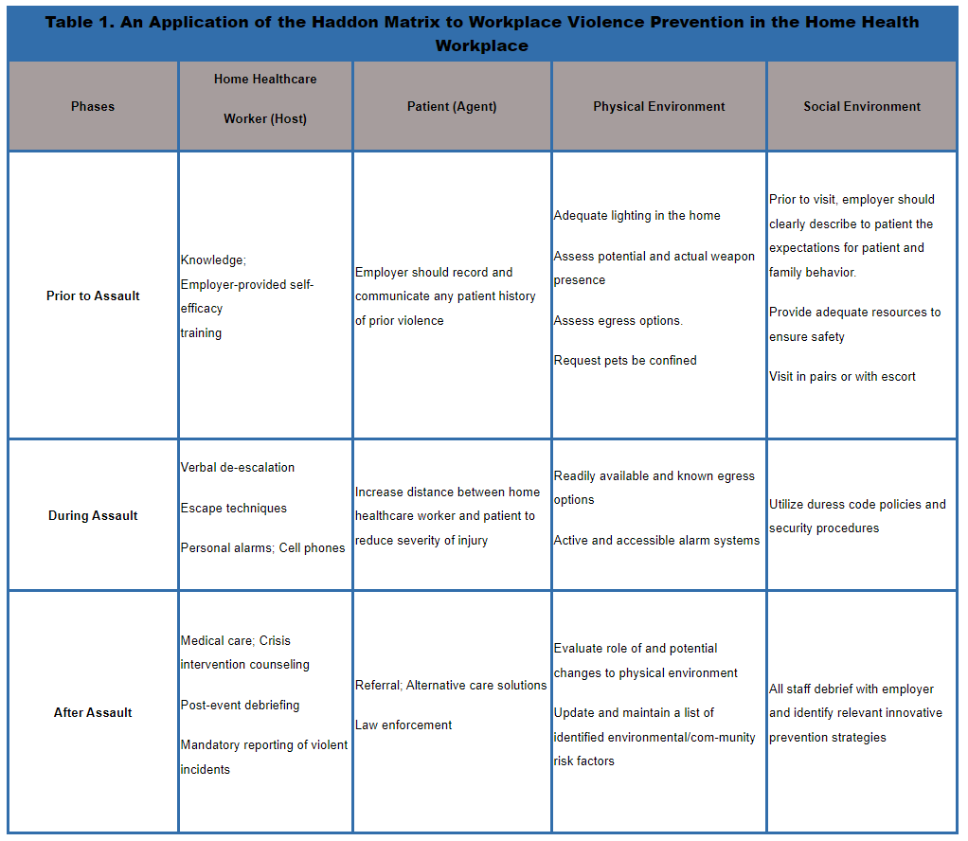
Home-Based Workplace Violence Program Checklist
Overall Workplace Violence Program ("WVP")
Agency has a workplace violence program (Includes written policy and training)
WVP program review to assess staff needs and training
Zero tolerance policy
Description of roles and responsibilities following violence
Program is reviewed and updated
Statement encouraging employee reporting
Policy to protect employees reporting violence
Management Commitment and Employee Involvement
Examine trends and patterns of violent events
Safety Committee that addresses workplace violence and safety
Field workers serve on committee
Psychological counseling or debriefing after event
Method to report or debrief near misses
Hazard Prevention and Control
Provide information about hazards & prevention to workers
Strategies for conducting home visits after dark
Strategies for ending a home visit early
Policies for using a buddy system (with a co-worker)
Policies for using any safety equipment or personal protective equipment
Safety and Health Training
Agency offers WVP training
Agency offers training to new employees
Agency offers ongoing training to employees at least annually
Every employee who sees [patients/clients] receives training
Training content includes customer service
Training content includes factors predicting violence and aggression
Training content includes characteristics of aggressive and violence [patients/clients] and families
Training content includes characteristics of hazardous households
Training content includes characteristics of hazardous neighborhoods
Verbal methods to diffuse aggressive behavior
Physical maneuvers to diffuse or avoid aggressive behavior
Self-defense if preventive action does not work
Policies and methods for reporting a violent event
Resources available for victims of workplace violence
Record Keeping and Program Evaluation
Maintain system for reporting violent events
Identify factors that contributed to violent event
Evaluate effectiveness of policies

